Contestant Number: ____________________
Time: ___________________
Rank: _______________



Payroll Accounting
(125)

NATIONAL 2024

CONCEPT KNOWLEDGE:

Multiple Choice (15 @ 2 points each) ________________ (30 points)
APPLICATION KNOWLEDGE:
Short Answer (14 @ 3 points each) ________________ (42 points)
Job 1: Employer Payroll Taxes ________________ (54 points)
Job 2: Recording Payroll ________________ (34 points)

TOTAL POINTS ________________ (160 points)

Test Time: 60 minutes

GENERAL GUIDELINES:
Failure to adhere to any of the following rules will result in disqualification:
- Member must hand in this test booklet and all printouts if any. Failure to do so will result in disqualification.
- No equipment, supplies, or materials other than those specified for this event are allowed in the testing area. No previous BPA tests and/or sample tests (handwritten, photocopied, or keyed) are allowed in the testing area.
- Electronic devices will be monitored according to ACT standards.
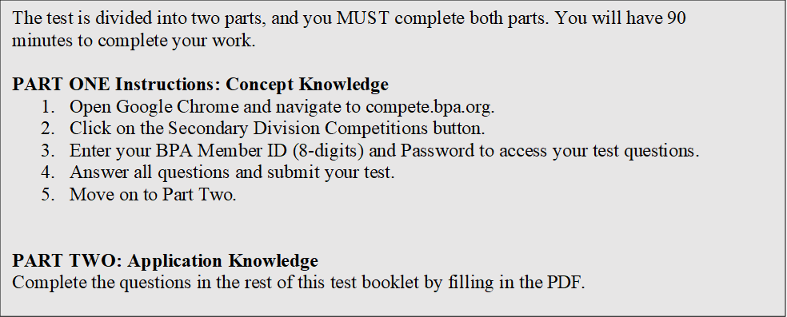EXAM GUIDELINES:
You have been hired as a Financial Assistant and will be keeping the accounting records for Digital Solutions, located at 700 Morse Road, Suite 201, Columbus, Ohio 43214. Digital Solutions provides accounting and other financial services for clients. You will complete jobs for Digital Solutions’ own accounting records, as well as for clients.

You will have 60 minutes to complete your work. The test is divided into two parts: concept knowledge and application knowledge.

Your name and/or school name should not appear on any work you submit for grading. Write your Member ID in the provided space. Staple all pages in order before you turn in your test.

Assumptions to make when taking this assessment:
- Round all percentages to two decimal places unless otherwise indicated.
- Assume all employees earn overtime for any hours worked over 40 hours in a week unless otherwise instructed.
- All calculations regarding time should be rounded to the nearest quarter hour.
- Use 6.2% for Social Security Tax on the first $100,000 in wages.
- Use 1.45% for Medicare Tax for all wages.
- Use 5.4% for State Unemployment Tax and 0.8% ($7,000 ceiling) for Federal Unemployment Tax.
- Assume no employee has accumulated earnings in excess of the social security tax, SUTA, or FUTA base unless otherwise indicated.
Multiple Choice Questions
Directions: Identify the letter of the choice that best completes the statement or answers the question.

- An employee earns $10 per hour and an additional 25 cents per hour for hours worked after 7:00 p.m. If an employee works from 2:00 p.m. to 11:00 p.m., with an unpaid meal break from 6:00 p.m. to 7:00 p.m., Monday through Friday, what is the employee’s weekly gross pay under the Fair Labor Standards Act.
  - $402
  - $403
  - $404
  - $405

- How many years must the employer retain copies of Form 940?
  - 2
  - 3
  - 4
  - 5

- A company has a gross payroll of $120,589.46 that is taxable for federal income, social security, and Medicare taxes. Federal income tax withheld is $24,117.87; combined social security and Medicare taxes withheld are $9,225.09. What are the company’s total withholdings for employees for this pay period?
  - $33,342.96
  - $42,568.05
  - $40,156.26
  - $66,685.92

- How often are Form 940 taxable wages reported?
  - monthly
  - quarterly
  - semi-annually
  - annually

- A payroll register for the pay period shows gross earnings of $300,000 and deductions of $120,000. What will the entry to the payroll expense account be?
  - $180,000
  - $300,000
  - $120,000
  - $420,000

- Which of the following taxes have to be paid by both the employer and the employee?
  - FUTA
  - SUTA
  - FICA
  - 401(k)

- Which form is used to request an employer identification number?
  - I-9
  - SS-4
  - SS-5
  - SS-8

- On a company’s financial statements, where do payroll taxes appear?
  - balance sheet
  - accrued payroll
  - income statement
  - salaries expense

- Which of the following documents proves an employee’s identity and authorization to work?
  - Form I-9
  - social security card
  - birth certificate
  - passport

- The entry to record paying the payroll includes a debit to what account?
  - Salaries Expense
  - Cash
  - Federal Income Tax Liability
  - Federal Unemployment Tax Liability

- How are salaries reflected on the income statement?
  - income
  - assets
  - accruals
  - expenses

- Failure to remit payroll taxes by their due date can have severe penalties.
  - True
  - False

- All of the following are considered withholdings from an employee’s gross pay except?
  - Court ordered withholdings
  - Federal income tax
  - Federal unemployment tax
  - Employee part of social security tax

- Supplemental wages paid to employees, such as bonuses and commissions, are not taxable.
  - True
  - False

- FUTA is reported on which form?
  - 940
  - 941
  - I-9
  - W4

Short Answer

- Robert worked for three employers during a calendar year earning $38,000, $39,000 and $45,000 respectively. What is the total amount of social security (6.2%) and Medicare taxes (1.45%) that would be withheld from Robert’s wages by the three employers?

 | YEARLY EARNINGS | SOCIAL SECURITY TAX | MEDICARE TAXES | TOTAL TAXES
Job 1 | $38,000.00
Job 2 | 39,000.00
Job 3 | 45,000.00
TOTALS

- Rob’s pay for this biweekly pay period showed the information below.

Vacation earnings: $576.62
Regular compensation: $239.38
401(k) pre-tax deferral: $48.50
Federal income tax rate to use: 22%

Find the following for Rob this pay period.

Total Earnings

Earnings after Deferral

Federal Income Tax Withheld

Net Pay

Job 1: Calculating Employer Payroll Taxes – 54 Total Points

Simpson Sports shows the following payroll information for two separate pay periods. For each pay period, find the FUTA earnings for each employee. Total both the current earnings, as well as the FUTA earnings for each period. Use the totals to calculate the employer taxes for each pay period. FUTA is only taxed on the first $7,000 of each employee’s earnings.

 |  | Pay Period Ending May 16th |  |  | Pay Period Ending May 30th
EMPLOYEE NAME |  | YTD ACCUMULATED EARNINGS | EARNINGS FOR CURRENT PAY PERIOD | FUTA EARNINGS | YTD ACCUMULATED EARNINGS | EARNINGS FOR CURRENT PAY PERIOD | FUTA EARNINGS
Arias, Samuel |  | $4,120.00 | $630.00 |  |  | $655.00
Carmona, Leonard |  | 5,725.00 | 930.00 |  |  | 915.00
Gonzalez, Justice |  | 7,580.00 | 1,265.00 |  |  | 1,310.00
Loaiza, Jose |  | 5,140.00 | 815.00 |  |  | 830.00
Parker, Jackson |  | 6,775.00 | 1,100.00 |  |  | 1,080.00
 |  | TOTALS |  |  | TOTALS
 | Social Security Tax Payable 6.2% |  |  |  | Social Security Tax Payable 6.2%
 | Medicare Tax Payable 1.45% |  |  |  | Medicare Tax Payable 1.45%
 | Unemployment Tax Payable – Federal 0.8% |  |  |  | Unemployment Tax Payable – Federal 0.8%
 |  | Total Payroll Taxes |  |  | Total Payroll Taxes

Job 2: Recording Payroll – 34 Points

Digital Solutions payroll register has the following totals for the semimonthly pay period, January 16 – 31, of the current year.

Total Earnings | Federal Income  Tax Withheld | Social Security  Tax Withheld | Medicare  Withheld
$15,640.00 | $1,015.00 | $969.68 | $226.78

Use the T accounts provided to analyze Digital Solution’s January 16-31 payroll.
On the cash payments journal, journalize the payment of Digital Solutions January 16-31 payroll. The payroll was paid by Check No. 776 on January 31 of the current year.

Salary Expense |  |  | Medicare Tax Payable
Employee Income Tax Payable |  |  | Cash
Social Security Tax Payable

DATE | ACCOUNT TITLE | CK NO. | POST REF | GENERAL
 |  |  |  | DEBIT | CREDIT

